Warning Signs hidden Beneath Planet Earth!
A Poem written by:
Haya Alnuaimi
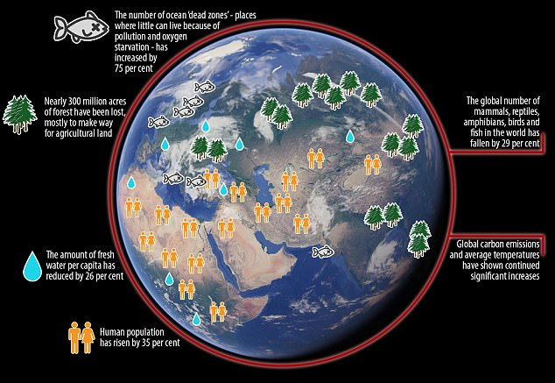
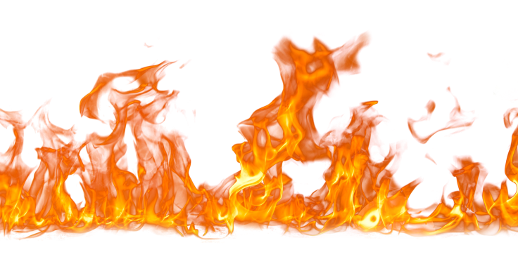
Warning Signs hidden Beneath Planet Earth!

Through the lenses of a caring person you’ll see
How beautiful our environment can be:
Where flowers grow
Animals reproduce
People start giving
working and recycling
Safe rains continuously fall
Until the oceans are filled
And countries stop starving!
The temperature’s balancing
It’s not heating; nor freezing
That’s the vision; so keep believing

But when hope starts fading
And people start panicking
That’s the beginning of losing
Our planet that was once a blessing

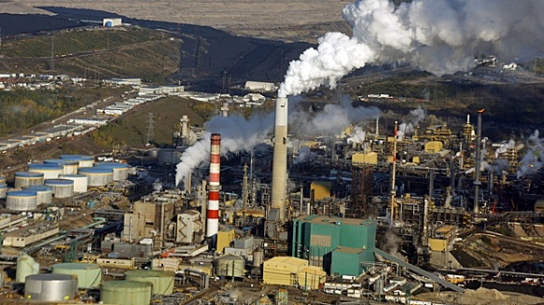
Near -sighted people are careless
They don’t see the truth behind their mess
When light turns to darkness
And rain particles become acid
When oxygen becomes CO2
We will die in seconds!

People go back to their religion
kneeling down; praying for permission
To seek for truth incomprehension
Sadly, none had the right vision
A bright future wasn’t their mission
Until oceans became dead water, there’s the lesson
When Mother Nature speaks disaster, like a hopeless person
No one knows the solution
In the end this was their entire conclusion

I speak to caution of nature’s wrath
So, always be careful of the aftermath
We, people must show the strength
To pull us together to have some faith
There is only one sentence to say
Remember to always choose the right way
Together we shall make a change
Without nature, we won’t be able to stay
So please, give Mother Nature a chance
To make our environment a better place
For humans and animals to have a legacy to trace.

